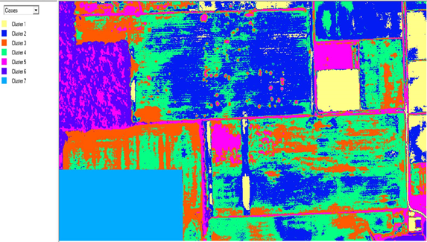

Cluster 7

Cluster 6

Cluster 5

Cluster 4

Cluster 3

Cluster 2

Cluster 1